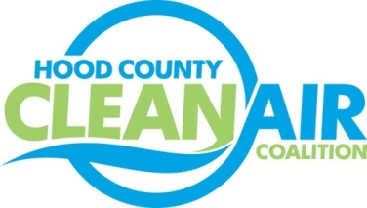
Meeting: Wednesday, March 2, 2016
American Town Hall
220 N. Travis Street, Granbury, Texas 76048
8:30-10:00 a.m.

Agenda

- Call Meeting to Order
- EPA Updates – Randy Pitre
- Regional Updates – Michelle McKenzie
  - Air Quality Funding Opportunities for Vehicles
  - Upcoming Alternative Fuel Vehicle Training Opportunities Calendar: sign up at: http://csrtc.nctcog.org/cvsfdropfull.aspx
    - March 29, 2016 – NAFTC Alternative Fuel Vehicle Safety Training for Firefighters
    - March 30, 2016 – NAFTC Alternative Fuel Vehicle Safety Training for EMS/Law Enforcement personnel
  - 100 Best Fleets Workshop in Fort Worth on March 22, 9-2:30 pm at City of Fort Worth Fleet Facility
- Local Updates – Michelle McKenzie
  - Review of January and February Meeting Summaries
  - Review of Projects
    - Monthly Budget Review for December and January (Rider 8 and Rider 7)
    - Closeout of Rider 8
    - Status of Projects FY 16/17
  - Reports
    - Clean Cities Webinar
    - Update for USDA Presentation on Rural Energy for America Program
  - HCCAC Activities
    - Annual Meeting End of April Schedule
    - Consideration of New Board Member
    - Consideration of Updated Expense Approval Process
    - Propane Fueling Station Ribbon Cutting – March 11th
5.) Discussion
6.) Adjourn

